Deuteronomy 29:9-29:14

Yom Kippur Morning Torah Reading – 1st Aliyah

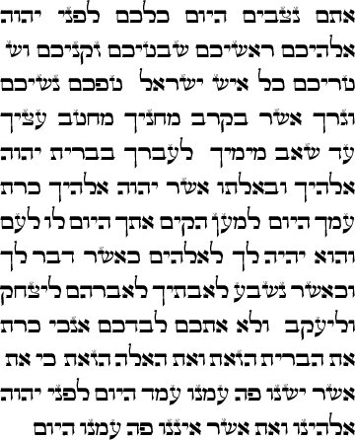 |  | 