Deuteronomy 30:11-30:14
Second Aliyah for Yom Kippur morning

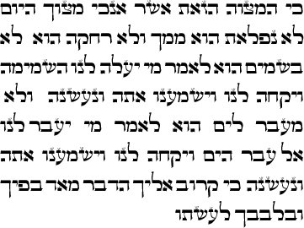 |  | 